**Block 1**

1. Adjust the bar menu as the previous Word file
2. Change the font and the color of this section "AR for everyone with Viewz the e-commerce soulmate" to be gradient as shown below:
   1. 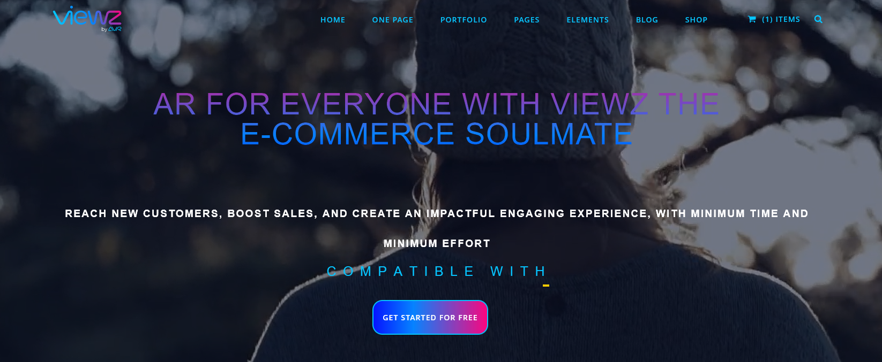
   2. Font: **Nunito** bold – Gradient: #06c4ff to #0683ff
3. Adjust the second sentence to:
   1. Font: **Nunito Regular – Color: White – 3 rows –** make it look like this:

Reach new customers, boost sales,

and create an impactful engaging experience,

with minimum time and minimum effort.

1. The third sentence:
   1. Try to remove the underscore or change its color
   2. Font: Source Serif Pro (Regular) – Color: make it white and when we add Hero Video maybe we will change the color.
2. CTA: adjust it to be like this:

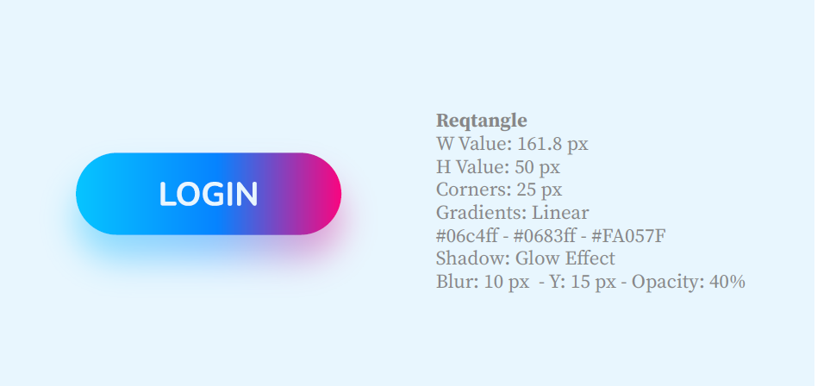

Increase the upper margin between it and upper text.

**Block 2**

1. BG: Color: e8f6fe (note: we will add a photo later)
2. Title: Font: Nunito Bold – Color: Gradient #06c4ff - #0683ff - #FA057F
3. Paragraph: Font: Source Serif Pro (Regular) – Color: #000A2A

**Block 3**

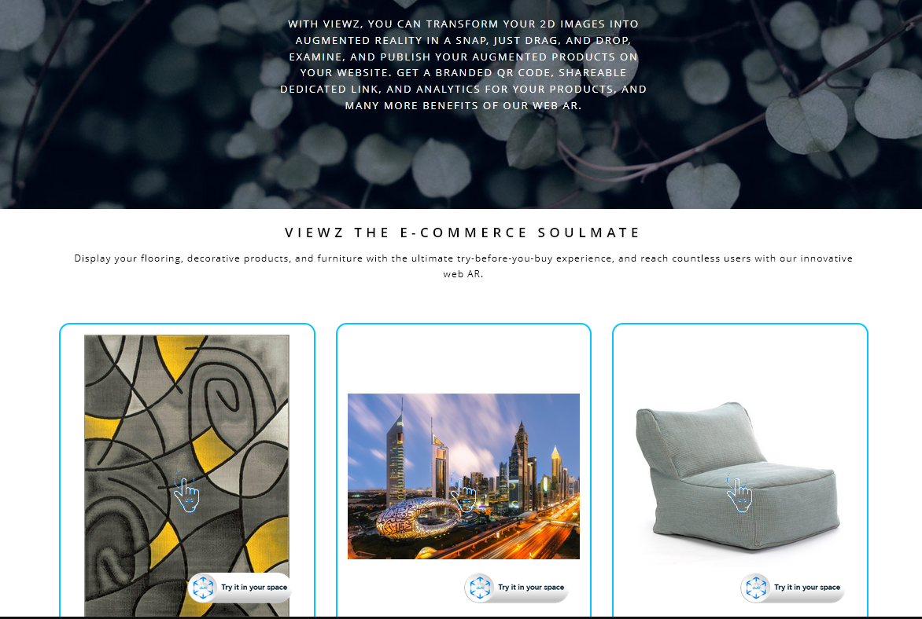

1. Title to be (Go viral with Viewz Web-AR) Font: Nunito Bold – Color: #0683ff – increase Top Margin.
2. Change the Sentence to:

Bring your customers a long-lasting impactful experience

and let them have real-time interactions with your products

in their own environment at any time.

**Block 4**

1. Change "**Industries" To "Solutions"**
2. Make it like (Go viral with Viewz Web-AR) sentence in size – Color: 06c4ff

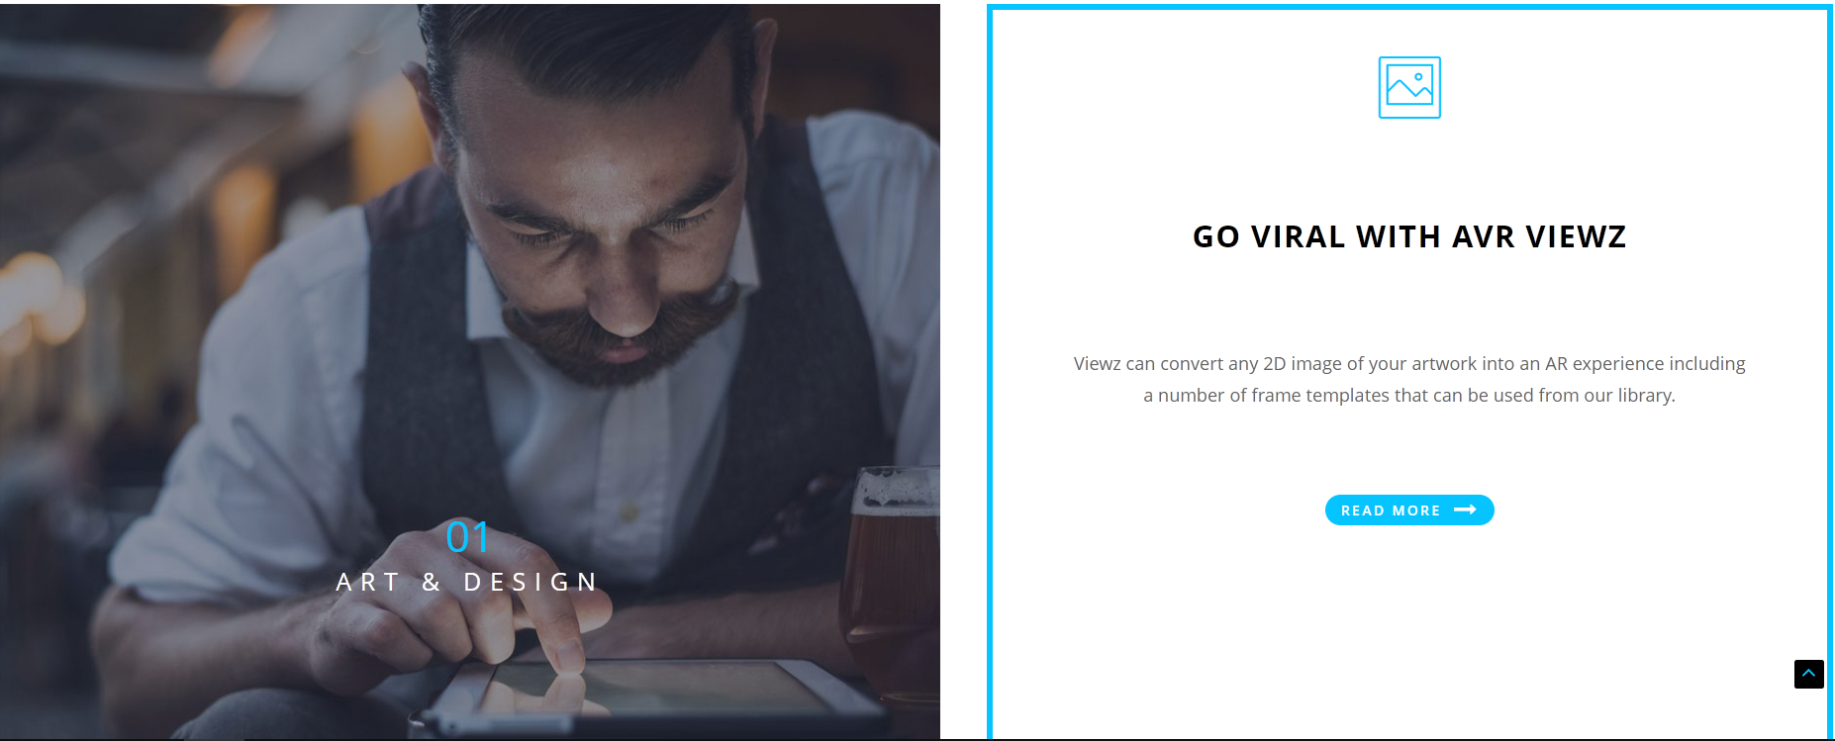

Please remove the blue rectangle and keep the content as below:

1. Title: "Go viral with AVR Viewz" change it to " AR your ART with Viewz" Font: Nunito Bold – color: 06c4ff

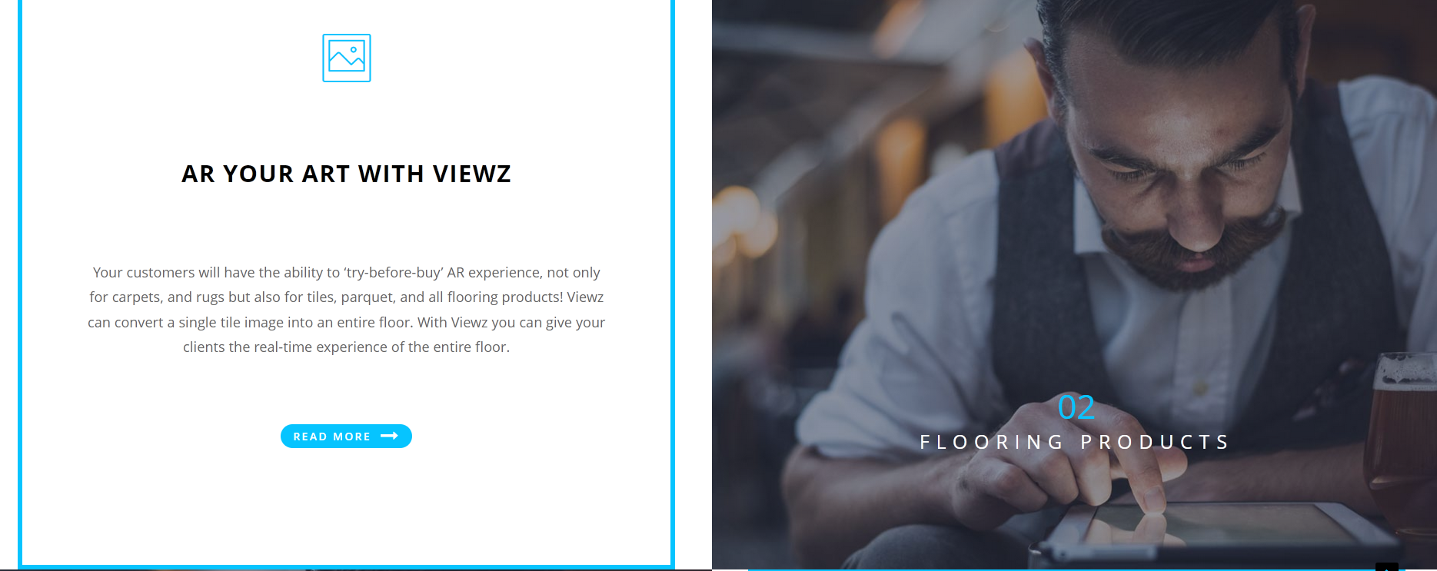

1. Title: change it to " Make sure your customers will not leave without making a purchase" Font: Nunito Bold – color: 06c4ff

|  |  |
| --- | --- |
|  | In this section:  Photo titles in 01, 02, 03, 04 must be like this:  **Font for Numbers**: Source Serif Pro Bold – Color: 06c4ff  **Font for Titles** (Art & Design, Flooring products, Wall Coverings, Furniture industry): Nunito Bold **–** Color: White  **Paragraphs:**  Font: Source Serif Pro Regular – Color: #000A2A |

**Block 5**

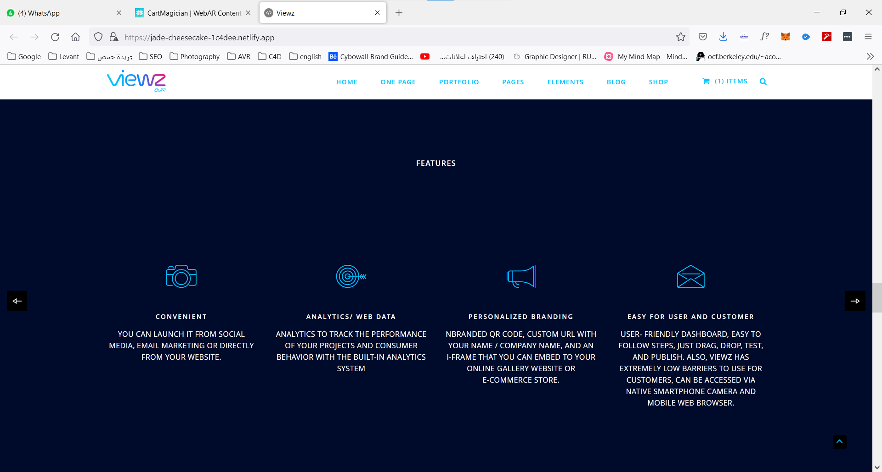

1. Change "Features" design to be like "Solutions" as above.
2. Make the features appear 3 by click (3 Features each slide)
3. We will provide you with the icons later.
4. Titles: Font: Nunito Bold – Color: #06c4ff
5. Paragraphs: Font: Source Serif Pro Regular – Color: #000A2A
6. BG Color: White

**Block 6**

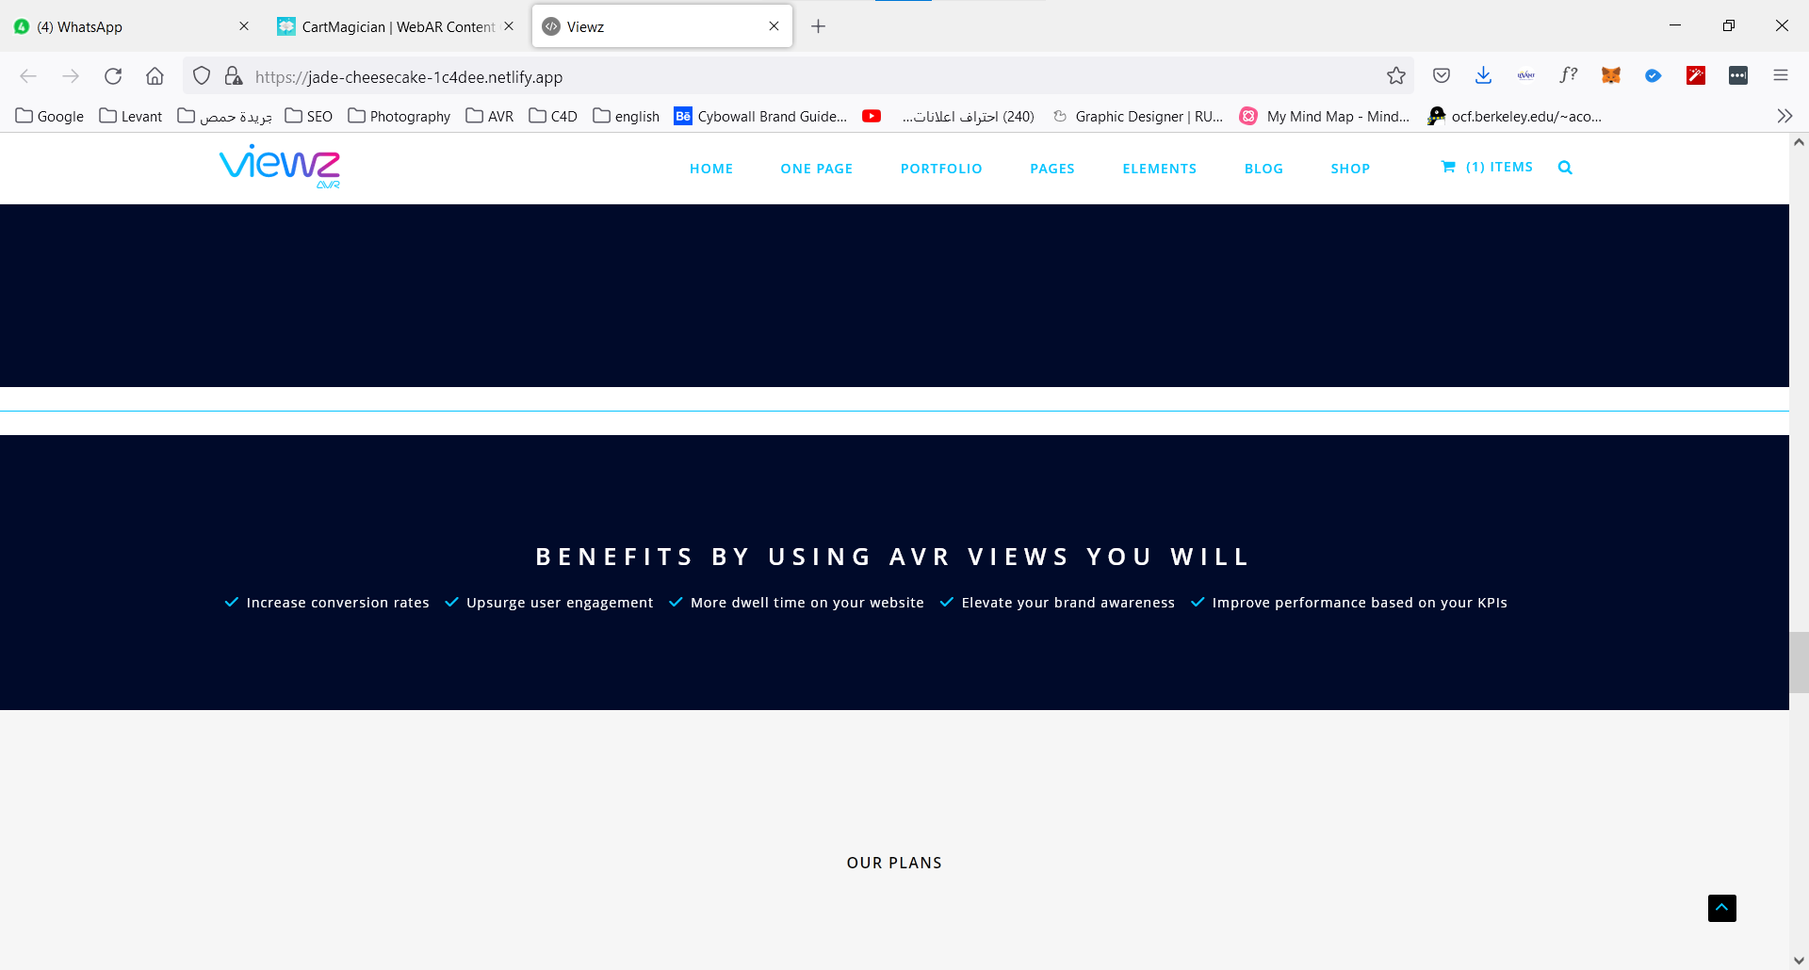

1. Title must be: "Benefits" and for the design to be like "Solutions" above and make them Bigger
2. First Sentence: **"By using Viewz you will"**

Font: Nunito Bold – Color: 06c4ff

1. Bullet Points:

2 by 2 and the last one below them in the middle…

1. BG color: #06c4ff

**Block 7**

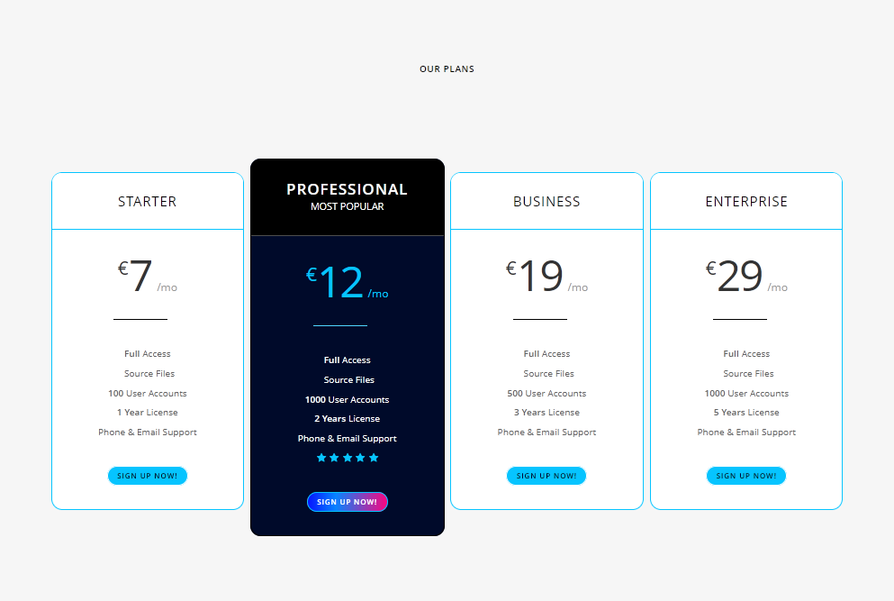

1. Change the title "Our Plans" to be as above: (like "Solutions")
2. Change titles ( Starter, Professional,… etc) to be:

Font: Nunito Bold – Color: #06c4ff

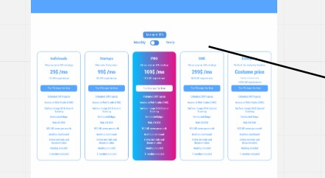

Changes the same as photo above

**Block 8**



1. BG color: #06c4ff
2. Title: change it to: "Subscribe to our Newsletter"
3. The search box text: "email" – icon: "arrow icon" Gradient color
4. Make the box full rounded.

**Block 9**

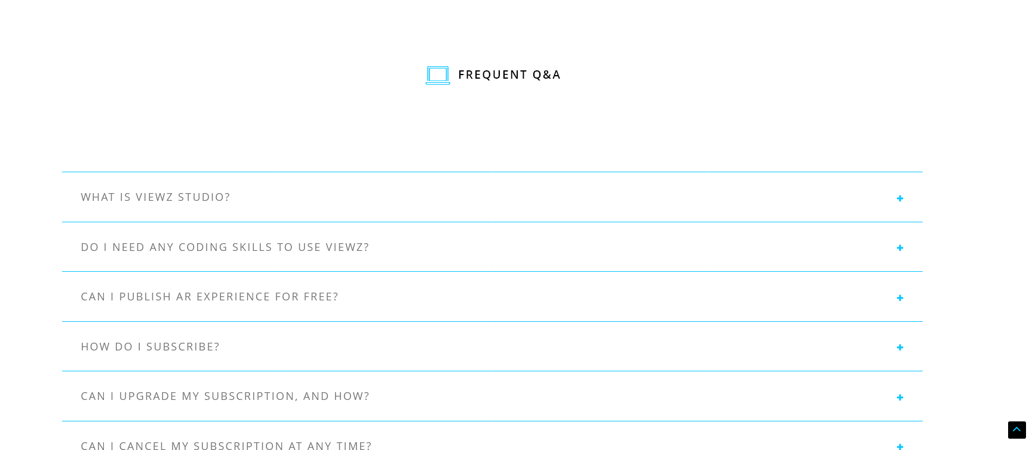

1. Title to be like Titles above. And change to "FAQs"
2. Questions :

Not "all cabs " mode make them normal Sentences

Font: Source Serif Pro Regular – color: #000A2A

**Block 10**

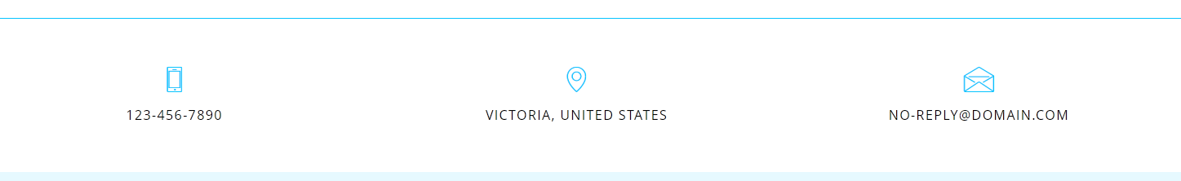

1. Remove it